CASHMERE VALLEY BANK
117 Aplets Way
PO Box G
Cashmere, Washington 98815

March 24, 2017

To the Shareholders of Cashmere Valley Bank:

THE DATE OF THE ANNUAL MEETING HAS BEEN CHANGED. THEREFORE. IF YOU HAVE PREVIOUSLY PROVIDED A PROXY CARD FOR THIS YEAR’S ANNUAL MEETING, YOU DO NOT NEED TO VOTE AGAIN AS YOUR RIGHT TO VOTE RELATES TO THE SHAREHOLDER OF RECORD DATE WHICH REMAINED FEBRUARY 21, 2017.

We cordially invite you to attend the 2017 Annual Meeting of Shareholders of Cashmere Valley Bank to be held on Tuesday, April 18, 2017, at 7:30 p.m. at 117 Aplets Way, Cashmere, Washington.

At the 2017 Annual Meeting, shareholders will vote to elect seven (7) persons to serve on the board of directors until the 2018 Annual Meeting of Shareholders.

Your vote is important. Whether or not you plan to attend the annual meeting, we hope that you will vote as soon as possible. We encourage you to promptly complete your proxy card. We have included a manual card as an attachment to this proxy statement for your convenience. If you attend the meeting in person, you may withdraw your proxy and vote your shares.

Further information regarding voting rights and the business to be transacted at the annual meeting is included in the accompanying proxy statement. Should you have any questions about the change in meeting date or the completion of your proxy card, please contact Tammy Marz at (509) 782-5492.

Your continued interest in and support of Cashmere Valley Bank is truly appreciated.
Sincerely,

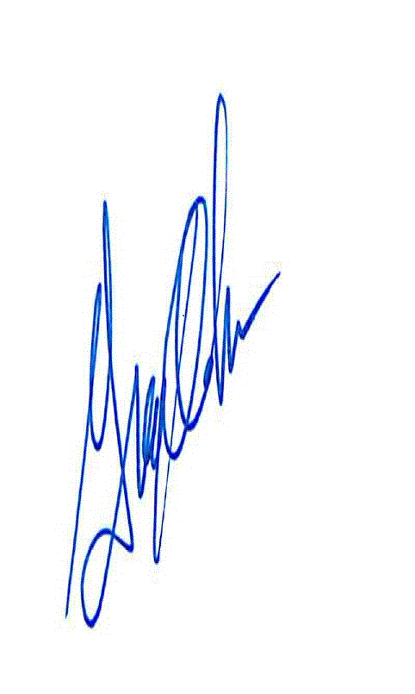

Greg Oakes
President and Chief Executive Officer
CASHMERE VALLEY BANK
117 Aplets Way
PO Box G
Cashmere, Washington 98815

Notice of Annual Meeting of Shareholders

TIME | 7:30 p.m. on Tuesday, April 18, 2017.
PLACE | 117 Aplets Way, Cashmere, Washington.
ITEMS OF BUSINESS | To elect seven (7) persons to serve on the board of directors until the 2018 Annual Meeting of Shareholders.
RECORD DATE | You are entitled to vote at the Annual Meeting and at any adjournments or postponements thereof if you were a shareholder at the close of business on February 21, 2017.
VOTING BY PROXY | Please submit your proxy card as soon as possible so that your shares can be voted at the Annual Meeting in accordance with your instructions.

By Order of the Board of Directors,

Greg Oakes
President and Chief Executive Officer

This proxy statement and the accompanying proxy card are being distributed on or about March 24, 2017.

PROXY STATEMENT

For Annual Meeting of Shareholders
to be held on April 18, 2017

INFORMATION ABOUT THE MEETING

Why did I receive these proxy materials?

We are providing the notice of Annual Meeting, this proxy statement and the accompanying proxy card (the “Proxy Materials”) for use in connection with the Annual Meeting of Shareholders of Cashmere Valley Bank (also referred to in this proxy statement as the “Bank,” “we” and “us”), to be held on Tuesday, April 18, 2017. These Proxy Materials are first being mailed to shareholders on or about March 24, 2017.
What proposals will be voted on at the Annual Meeting?

At the Annual Meeting, holders of our common stock will be asked to consider and act upon the following proposals:

- Election of Directors. Election of seven (7) persons to serve on the board of directors until the 2018 Annual Meeting of Shareholders.

How does the board of directors recommend I vote?

The board of directors unanimously recommends that you vote:

- “FOR” the election of the director nominees.

What vote is required to approve the proposals?

- Election of Directors. To elect the director nominees, we must receive the affirmative vote “FOR” the director nominees by a majority of the total votes represented and entitled to be cast at the Annual Meeting. Votes that are withheld and broker non-votes will have no effect on the outcome of the election.

How will my proxy be voted?

Shares represented by properly executed proxies that are received in time and not revoked will be voted in accordance with the instructions indicated on the proxies. If no instructions are indicated, the persons named in the proxy will vote the shares represented by the proxy as recommended by the board of directors.

Can I revoke my proxy?

Any proxy given by a shareholder may be revoked before its exercise by (1) giving notice to us in writing, (2) delivering to us a subsequently dated proxy, or (3) notifying us at the Annual Meeting before the shareholder vote is taken.

Who is soliciting proxies?

Our board of directors is soliciting proxies from the holders of our common stock, and we will pay the associated costs. Such costs are expected to be limited to mail and telephone expenses.

Who is entitled to vote?

Shareholders who owned our common stock as of the close of business on February 21, 2017 (the “Record Date”) are entitled to vote at the Annual Meeting. There were approximately 4,100,966 shares of our common stock issued and outstanding on the Record Date, and each share of common stock is entitled to one vote on each proposal.

Brokers holding shares of record for customers generally are not entitled to vote on certain matters unless they receive voting instructions from their customers. As used herein, “broker non-votes” means the votes that could have been cast on the matter in question by brokers if the brokers had received their customers’ instructions. A broker non-vote occurs when a broker holding shares of common stock for a beneficial owner votes on at least one proposal but not on another because the broker does not have discretionary voting power with respect to that item and has not received instructions from the beneficial owner.

What is the quorum requirement for the Annual Meeting?

The quorum requirement for holding the Annual Meeting and transacting business is a majority of the total votes entitled to be cast at the Annual Meeting, represented in person or by proxy. The shares may be present in person or represented by proxy at the Annual Meeting. Both abstentions and broker non-votes are counted as present for the purposes of determining the presence of a quorum.

PROPOSAL NO. 1: ELECTION OF DIRECTORS

The Bank’s Articles of Incorporation provide that the number of directors to be elected by the shareholders will be at least five (5) and not more than seven (7), the exact number to be determined by resolution of the Board. The Board has fixed the number of directors to be elected at the Annual Meeting at seven (7) and has nominated the persons listed in the following chart for election as directors to serve until the 2018 Annual Meeting of Shareholders or until their successors are elected and qualified.

Name | Principal Occupation
Brian Nelson, Chairman | Owner, Valley Tractor
Lyman Boyd, Vice Chairman | Owner, Linderhof Inn and Bavarian Lodge
Judy Conner | Former Principal, Of Counsel,  Certified Public Accountant,  Cordell, Neher & Company, P.L.L.C.
John Doyle | Chief Financial Officer,  Confluence Health
William Dronen | Former Administrator, Cashmere Convalescent Center
Keith Wiggins | Owner, Boswell’s Furniture
Greg Oakes | President, Chief Executive Officer,  Cashmere Valley Bank

If any nominee should refuse or be unable to serve, the proxy will be voted for such person as shall be designated by the board of directors to replace such nominee. The board of directors presently has no knowledge that any of the nominees will refuse or be unable to serve. Other nominations, if any, may be made only in accordance with the prior notice provisions contained in the Bank’s Bylaws, which may be requested from InvestorRelations@CashmereValleyBank.com.

Votes Required and Board Recommendation

The affirmative vote of the holders of a majority of the total votes represented and entitled to be cast at the Annual Meeting is required to elect the director nominees. The board of directors unanimously recommends that the shareholders vote “FOR” the election of the director nominees.

OTHER MATTERS

The board of directors knows of no other matters to be brought before the Annual Meeting.
ANNUAL REPORT
A copy of the 2016 Annual Report to Shareholders serves as the Bank’s Annual Disclosure Statement and will be first mailed to registered shareholders on March 31, 2017. Additional copies of the Bank’s Annual Report, including Annual Financial Statements, or other information may be obtained at www.cashmerevalleybank.com/investor-relations or requested from the Bank (InvestorRelations@CashmereValleyBank.com or 509-782-2624).

PROXY

2017 ANNUAL MEETING OF SHAREHOLDERS
CASHMERE VALLEY BANK

The undersigned shareholder of CASHMERE VALLEY BANK, Cashmere, Washington (the “Bank”) hereby appoints Brian Nelson and Greg Oakes, each with the full power to act alone and with full power of substitution, to vote as my proxy all of the common stock of the Bank held in my name on the books of the Bank as of February 21, 2017, at the Annual Meeting of Shareholders, to be held at 117 Aplets Way, Cashmere, Washington on Tuesday April 18, 2017, at 7:30 p.m., or at any adjournments, with all the powers I would possess if personally present, as follows:

- ELECTION OF DIRECTORS. Electing these seven (7) nominees to the board of directors to serve until the 2018 Annual Meeting of Shareholders and until their successors are elected and qualified.

Brian Nelson Lyman Boyd Judy Conner John Doyle

William Dronen Keith Wiggins Greg Oakes
□ FOR all nominees listed above □ WITHHOLD AUTHORITY to vote

THIS PROXY IS BEING SOLICITED ON BEHALF OF THE BOARD OF DIRECTORS OF THE BANK AND WILL BE VOTED “FOR” THE PROPOSALS LISTED ABOVE UNLESS AUTHORITY WITHHELD OR A VOTE AGAINST IS SPECIFIED, IN WHICH CASE THIS PROXY WILL BE VOTED IN ACCORDANCE WITH THE SPECIFICATION SO MADE.

The board of directors knows of no other matters that may properly be, or which are likely to be brought before the meeting.

The board of directors unanimously recommends a vote “FOR” the election of the director nominees.

DATED: _____________________, 2017 | No. of Shares Owned: _______________
Signature of Shareholder | Signature of Shareholder
Print Name of Shareholder | Print Name of Shareholder

WHEN SIGNING AS ATTORNEY, EXECUTOR, ADMINISTRATOR, TRUSTEE OR GUARDIAN, PLEASE GIVE FULL TITLE. IF MORE THAN ONE TRUSTEE, ALL SHOULD SIGN. ALL JOINT OWNERS MUST SIGN. IF A CORPORATION, PLEASE SIGN IN FULL CORPORATE NAME BY PRESIDENT OR OTHER AUTHORIZED OFFICER. IF A PARTNERSHIP, PLEASE SIGN IN PARTNERSHIP NAME BY AUTHORIZED PERSON.

